1) Remarkable technical advancements in Femtosecond lasers for Medical Applications
https://www.osa-opn.org/home/newsroom/2018/june/femtosecond_lasers_for_noninvasive_vision_correcti/

Femtosecond Lasers for Noninvasive Vision Correction
Molly Moser - Optics and Phonics News, June 2018
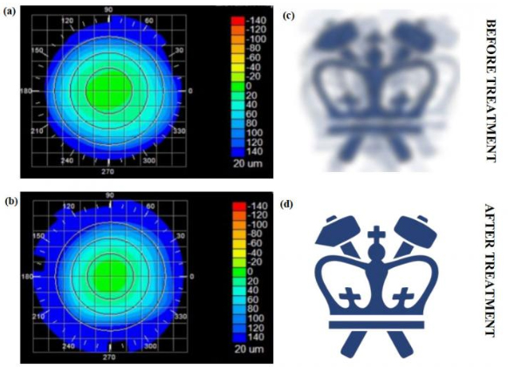
Corneal topography before and after the Columbia team’s fs laser treatment, paired with “virtual” vision simulating the effects of the induced refractive-power change. [Image: Sinisa Vukelic/Columbia Engineering]
By 2020, some 2.5 billion people worldwide may be affected by myopia, or nearsightedness. Corneal refractive surgery has emerged in recent decades as a more permanent fix for the condition than glasses or contact lenses—but vision surgery is invasive, and subject to post-surgical complications and even vision loss in rare cases.
Now, a research team at Columbia University, USA, has developed a noninvasive technique that it says can permanently correct vision (Nat. Photon. doi: 10.1038/s41566-018-0174-8). The method relies on a low-powered ultrafast laser and photochemical effects to alter biochemical and biomechanical properties of corneal tissue. According to the researchers, this nonsurgical technique, which has fewer side effects and limitations than refractive surgeries, could lead to treatment for myopia, hyperopia, astigmatism and irregular astigmatism.

Looking past LASIK
Laser-assisted vision correction surgeries such as laser in situ keratomileusis (LASIK) and photorefractive keratectomy (PRK) have high success rates, but the ablative technology, which can thin and even weaken the cornea, comes with risks and a number of reported side effects. Moreover, some patients (such as those with dry eyes, thin corneas and other abnormalities) are not good candidates for refractive surgery. As an alternative, Columbia Engineering researcher Sinisa Vukelic and his team propose a nonsurgical technique for permanent vision correction that reportedly avoids thermal ablation and optical breakdown.
The technique achieves those advantages through a different mode of laser–cornea interaction: it relies on a femtosecond oscillator that pulses very low energy at a high repetition rate to change the localized tissue’s macroscopic geometry. This kind of ultrafast laser lets the team use just enough power to induce low-density plasma (LDP), but not so much energy that the tissue is damaged. “This is a fundamental departure from the mainstream ultrafast laser treatment,” Vukelic explained in a press release, that “relies on the optical breakdown of the target materials and subsequent cavitation bubble formation.”

Building corneal crosslinks
The critical element of this approach is the induction of the LDP, which causes ionization of water molecules in the cornea. The ionization, in turn, creates a reactive oxygen species—an unstable molecule that contains oxygen and reacts easily with other molecules in a cell—which then interacts with the surrounding collagen proteins in the cornea to form crosslinks without the use of photosensitizers. The crosslinking alters collagen properties in the selected regions, resulting in changes to the cornea as a whole.
With this treatment, the team notes, only the targeted molecules are ionized, so optical breakdown of the corneal tissue is avoided. As the process is photochemical, tissue is not disrupted, and the induced changes remain stable.

Ex vivo and in vivo experiments
As a proof of concept, the team applied its method to pig eyes ex vivo, measuring the difference in corneal curvature, which in turn corresponds to the change in effective refractive power (ERP) after both corneal flattening and corneal steepening. (Corneal flattening is used to treat myopia; corneal steepening is a treatment for hyperopia, or farsightedness.) Over 24 hours, the team observed a strong change in ERP, followed by partial recovery and stabilization at about 3.45 diopters, on average.
After treatment, the team tested for laser-induced changes in corneal temperature, for corneal hazing and for changes in crosslink density. The researchers observed no laser-induced damage under standard histological examinations and confocal imaging—which, they suggest, confirms that the femtosecond laser treatment effectively changed the refractive power of the pig eye without adverse side effects.
The researchers followed up those ex vivo experiments with in vivo tests on rabbit eyes. Tracking changes in ERP regularly over three months after treatment, the team found that those changes remained stable for three months, with a relative change in ERP of about 1.94 diopters. Histological examination revealed no thermal damage to stromal tissue, confirming the safety of the treatment, according to the team. Confocal imaging of the rabbit eyes revealed no difference in cellular structure or density after laser treatment.

Non-ocular possibilities
According to Vukelic, this technique can be applied to other collagen-rich tissues and could potentially be used to treat non-ocular conditions, such as early osteoarthritis. The team believes that this method could widen the pool of eligible patients for permanent vision correction, as well as eliminate the post-surgical complications associated with LASIK and PRK. “We think our non-invasive approach has the potential to open avenues to treat or repair collagenous tissue without causing tissue damage," said Vukelic.
2) New fiber optics for short wavelength, short pulsewidth high power lasers
https://www.photonics.com/Articles/Fiber_Optics_for_High-Power_Applications/p5/vo170/i1115/a64285

Fiber Optics for High-Power Applications
As new applications require more laser power, components make the difference between success and failure for fiber optics laser and delivery systems.
PIERRE LAPERLE, OZ OPTICS LTD. – Photonics Spectra, Feb 2019
Specialty fiber components are an increasingly important part of generating and transmitting high-power laser beams for applications ranging from materials processing to laser surgery to lidar. These applications require precision — with minimal surrounding damage — and accuracy, both of which can be achieved with a high-quality (diffraction-limited) laser beam.
Since the late 1980s, single-mode fibers (SMFs), which offer such beam quality, have been used in fiber lasers in a laser diode core-pumped configuration, generating tens of mW of power. The advent of the clad-pumping scheme in the 1990s permitted a jump in power to a few watts, but for today’s uses, scaling output power into the tens, hundreds, or thousands of watts has been hindered by thermal loading and nonlinear effects. The key to unleashing power is to use larger core fibers and pumping schemes to distribute thermal load and to increase the power threshold of nonlinear effects. The building blocks of fiber laser and delivery systems are components that can manipulate light in such a way as to link different parts of the laser with minimal loss.
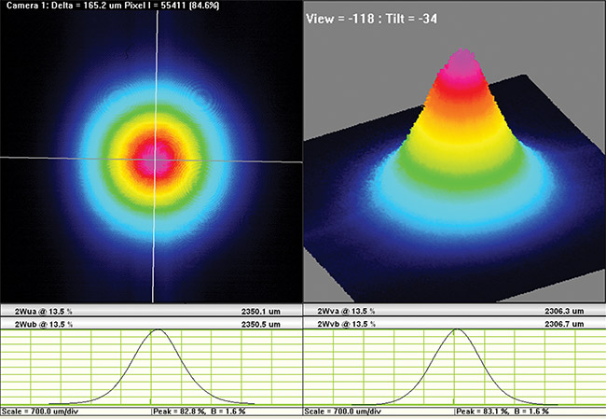

Figure 1. Diffraction-limited beam profile of a fiber with end cap for high-power applications. Courtesy of OZ Optics.

Unfortunately, SMFs have narrow cores. When exposed to high power densities and undesired nonlinear effects, they suffer from catastrophically damaged end faces, which limits achievable power. Components such as mode field adapters (MFAs), combiners, and end caps, however, enable fiber lasers to scale power (Figure 1).
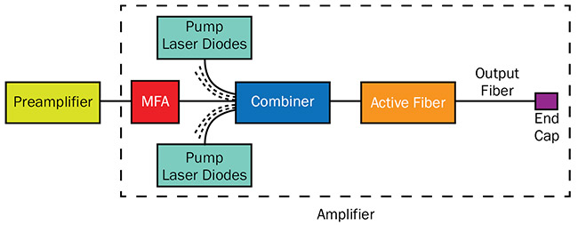

Figure 2. Schematic diagram of a master oscillator and power amplifier (MOPA) laser system in which mode field adapter (MFA), combiner, and end cap are used. Courtesy of OZ Optics.

Components are typically used in a master oscillator and power amplifier (MOPA) system, which is a laser system consisting of a preamplified seed laser plus a laser amplifier for increasing the output power (Figure 2). An MFA matches the laser beam size of the SMF from the preamplifier to the large-mode-area (LMA) active fiber of the amplifier stage to achieve minimal loss, a combiner couples several pump laser diodes into the active fiber cladding of the amplifier stage, and an end cap on the output fiber reduces the power density to below the damage threshold of the fiber. These components are also used in collimators and isolators, for sealing photonic crystal fibers, and for matching dissimilar fibers for R&D and industrial applications.
High-power limitations
Fiber systems contend with various limitations, including the fibers themselves, their end faces, damage threshold, dispersion of laser energy, and back reflection, all of which must be managed effectively when designing and choosing fibers for high-power applications.
An optical glass fiber (defined as glass by its core and clad chemical composition and fabrication) can sustain damage. For example, damage at the end face of an optical fiber used in laser beam delivery is attributed mainly to a thermal failure mode for CW and pulsed laser beams, and to dielectric breakdown of defects in the case of ultrafast pulses. The laser beam energy is partially absorbed by irregularities at the glass/air interface, where heat builds and leads to catastrophic damage.
Damage threshold determines the power density that a glass fiber can handle, so it must also be considered. Defined by the laser beam wavelength, damage threshold is expressed in W/cm² (or the maximum fluence in J/cm² for pulsed laser). For example, a photon at 532 nm has twice the energy of a photon at 1064 nm. In this case, the damage threshold at 532 nm will be at least half of what it is at 1064 nm. In practice, the damage threshold is much less than half. It scales nonlinearly with photon energy, as new damage mechanisms appear.
Fiber laser systems are used to generate high-power laser beams but the power they can achieve is limited by nonlinear effects that disperse the laser energy. Stimulated Brillouin scattering (SBS) and stimulated Raman scattering (SRS) are the two main nonlinear effects. Brillouin scattering refers to the scattering of light from acoustic waves generated through electrostriction. As the input power increases, a threshold level is reached and the scattering process becomes stimulated, causing saturation of the main laser power. Raman scattering refers to the scattering of light from vibrating glass molecules, which shifts the scattered light to higher wavelengths. SRS occurs when an input power threshold level is reached and power is taken away from the main lasing to SRS. Both SBS and SRS power thresholds are proportional to the laser’s effective mode area.
Manipulating power density
Fiber heat load can be managed in sev-eral ways, for example by adding end caps, which reduce the power density at the tips of fibers in laser beam delivery systems to below the damage threshold at the glass/air interface. An end cap is a short piece of fused silica, also known as coreless fiber, which is spliced to the end of the fiber (e.g., SMF, multimode fiber [MMF], LMA fiber, or holey fiber). As the guided laser beam traveling down the fiber reaches the end cap, the beam is free to expand and the power density drops at the glass/air interface (Figure 3). The angular spread of the beam in the end cap depends on the numerical aperture (NA) of the fiber. The end cap length and diameter are adjusted to achieve the required power density at a specific wavelength or wavelength range.
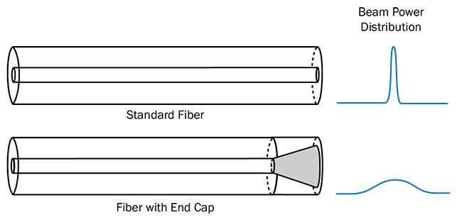

Figure 3. Schematic diagram of an end cap and its effect on light propagation to decrease the output power density. Courtesy of OZ Optics.

In manufacturing an end cap, beam quality, NA, and polarization extinction ratio for polarization maintaining (PM) fibers must be considered1. The fiber core deformation (and stress rod deformation in the case of PM fibers) needs to be minimized during the fusion splicing between the coreless fiber and the guiding fiber to conserve the output characteristic of the laser beam. Another determinant factor for power handling is how the end-capped fiber face is prepared. It can be either cleaved or polished, and in some cases an antireflection (AR) coating can be added. For cleaved end caps, any defects such as scribe and surface marks will reduce the power handling. For polished end caps, it is very important to remove any surface contamination from the polishing process; ultrasonic cleaning is commonly used in such cases. Tiny scratches left by the polishing pad can be removed by conditioning with a CO₂ laser to even out the glass end face (Figure 4).
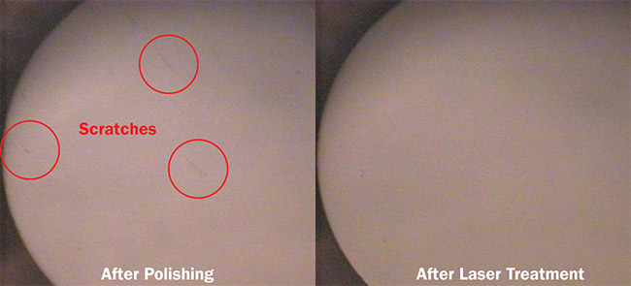

Figure 4. Comparative view of optical fiber surface quality after polishing and after laser treatment. Courtesy of OZ Optics.

An AR coating is added to the end-capped fiber face to minimize back reflection, which can cause power instabilities. However, this is done at the expense of reducing the power handling because some energy from the beam can be absorbed or scattered in the AR coating layers. The amount of internal stress in the AR coating will also affect the speed at which failure occurs.
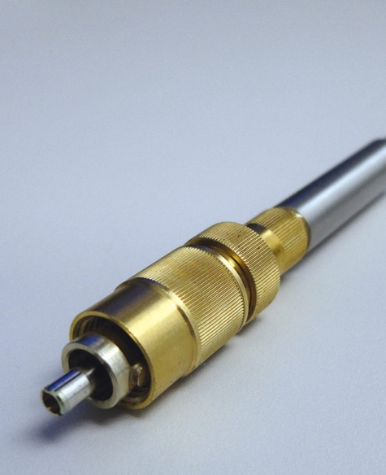

Figure 5. High-power, end-capped air-gap ferrule connector (FC) with adjustable ferrule. Courtesy of OZ Optics.

An additional way to manage fiber heat load is to use an air-gap connector design. In a standard design, where the fiber is glued to the connector ferrule, the heat generated at the tip of the end cap can burn the epoxy and leave residues on the end face, leading to catastrophic damage. In an air-gap ferrule connector (FC) or a subminiature version A (SMA) connector design, the end-capped fiber typically protrudes a few millimeters from the connector body so that heat can be safely dissipated. The connector can also feature an adjustable design where the ferrule position is moved for maximum laser beam coupling in fiber delivery systems (Figure 5). In order to accommodate the required power density, the end cap diameter will vary from being identical to the fiber it is spliced on to a few millimeters larger.
Reducing nonlinear effects
In laser systems where nonlinear effects must be reduced while saturation energy must be increased to reach high powers, MFAs are used to change the mode field diameter (MFD) of one fiber to match the MFD of another fiber in order to achieve low loss. The most common technique to reduce nonlinear effects, though, is to increase the core diameter of the fiber. When this is done, the MFD of the active fiber used in the high-power laser stage will no longer match the MFD of the fiber used at the low-power preamplifier stage. Connecting the two stages directly would result in high losses. The MFA bridges the gap between the two stages.
Two techniques are commonly used to adjust the MFD. One of these is thermally expanded core (TEC), which increases the core size and decreases the NA over a short section. It is well-suited for increasing the MFD of SMFs but not for decreasing the MFD of LMA fibers². TEC involves heating the smaller core size fiber to high temperatures, usually in arc or CO₂ fusion fiber splicers. The arc or CO₂ power is adjusted to transfer enough heat to diffuse the core dopants radially without altering the external diameter of the fiber. The amount of diffusion is governed by the exposure time. Figure 6a illustrates an SMF spliced to an LMA fiber with and without a TEC. Using a TEC can generally limit loss attributable to mode mismatch to below 0.5 dB; without TEC, the loss can be as high as several dB.
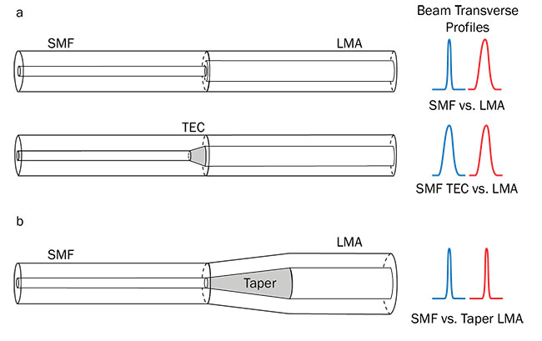

Figure 6. Schematic diagram of a single-mode fiber (SMF) without and with a thermally expanded core spliced to a larger core large-mode-area (LMA) fiber (a), and a tapered LMA fiber (b). The laser beam transverse profiles are illustrated at splice interfaces. TEC: thermally expanded core. Courtesy of OZ Optics.

Tapering is another way to adjust the MFD. With this technique, the larger fiber is heated and elongated to create a tapered profile, which is then spliced to the smaller fiber (Figure 6b). Similar to TEC, arc or CO₂ laser fiber fusion splicers are used for tapering. The core ratio and the length of the taper need to be carefully calculated to achieve an adiabatic transfer of the beam energy. Any leak of light outside the core will result in a hot spot, causing damage. This technique is limited by the core size and length that can be achieved in a splicer. For very dissimilar fibers, TEC and taper techniques can be combined to match their mode field diameters.
Power scaling
A combiner or pump combiner is primarily used in fiber laser systems to bring the pump light into the active fiber of the laser. Pump combiners are an essential part of fiber laser systems, allowing power scaling to kW levels. Combiner configurations can be end clad-pumped or side clad-pumped, but the former is used most often³. The basic form of the end-pumping configuration consists of multimode fibers arranged in a bundle and tapered to match the cladding size of the active fiber (Figure 7a). The combiner bundle and the active fiber are cleaved and spliced together. For MOPA systems, the pumping configuration can be forward or backward with respect to the signal propagation. In this case, the combiner becomes more complex, integrating a signal fiber in the center of the fiber bundle (Figure 7b). To minimize coupling loss between the signal fiber and the active LMA fiber, an MFA is added to the signal fiber.
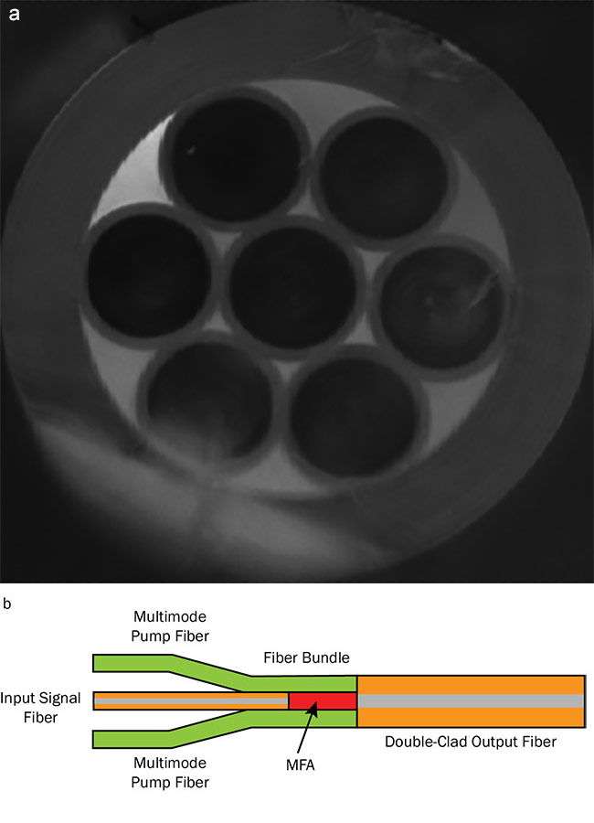

Figure 7. A typical 7×1 combiner fiber bundle (a); and the basic principle of a combiner with signal fiber for high-power fiber laser systems (b). Courtesy of OZ Optics.

Several techniques, such as TEC⁴ or tapering, may be used to fabricate the MFA. Types of combiners include N×1, which combines N pump lasers into one output fiber, and (N+1)×1, which combines N pump lasers and one signal fiber into one output fiber. The signal fiber can be either PM or non-PM.
One common technique to fabricate end-pumped combiners is to overclad a bundle of fiber with a glass capillary and taper it down to the appropriate size in a fusion splicer. The adiabatic criterion for tapers also applies for combiners. The challenge of fabricating a combiner is to bring the fiber bundle into a tight fit to minimize the deformation of fibers during the tapering, especially of the signal fiber. The glass capillary and fibers assembly also needs to be contaminant-free to eliminate hot spots during high-power laser operation.
Development of end cap, MFA, and combiner for various optical fibers and new application requirements is an ongoing process. These components are the backbone of high-power fiber delivery and laser systems. Without them, combining the flexibility and low maintenance of fibers and high-power laser beams would not be achievable. Technical knowledge of fiber properties and fabrication is necessary for the design of low-loss and high-power handling components. Furthermore, the availability of high-precision glass processing equipment combined with the best practices and technical know-how in the manufacturing environment make the development of specialty fiber components easier and more competitive.

3) Tunable Visible Spectrum LED and Laser Light Sources
https://www.photonics.com/Products/Tunable_LED_Light_Source/p5/vo149/i1026/pr63519

Tunable LED Light Source
Photonics Spectra, Dec 2018 / Gamma Scientific Request Info

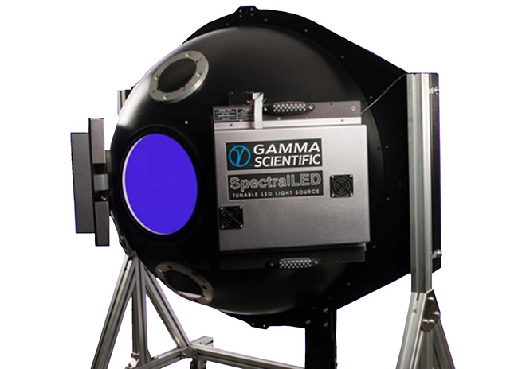

The SpectralLED RS-7-2 tunable LED light source platform from Gamma Scientific Inc. incorporates 35 LED wavelengths for the synthesis of commercially available light sources such as CIE Illuminants A, B, C, D50, D55, D65, D75, E, and F1-F12, or based on imported spectral profiles.
Ideal for applications requiring flat-field calibration, the product range is ideal for test and characterization of telescope or telephoto lenses for aerospace, and fish-eye and wide-angle lenses for consumer-related products, as well as any of a number of test applications for large-area image sensors.
The product line features a spectral range from 380 to 1000 nm with illumination stability greater than 99.99 percent. The illumination accuracy is NIST traceable to >3 percent with full-scale linearity >0.1 percent rms. Through the 16-bit DAC current drivers, users can achieve up to 5 decades of dynamic range adjustment with wavelength monitoring and a spectral accuracy >0.25 nm. The firmware includes full spectral calibration with spectral fitting and storage of presets.

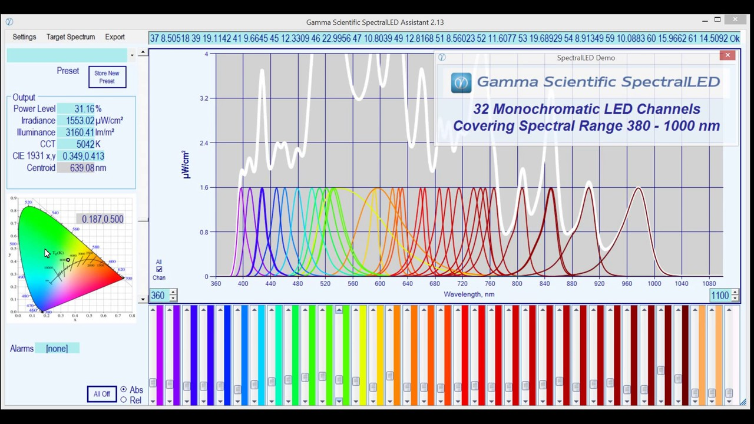

Tunable Laser Light Sources Advance Nanophotonics Research
Optical parametric oscillators offer a competitive alternative to conventional lasers for molecular physics and quantum nanophotonics.
JAROSLAW SPERLING AND KORBINIAN HENS, HÜBNER PHOTONICS – Photonics Spectra, Oct 2018
A considerable part of contemporary photonics research that investigates the interaction of light with nanoscale objects — nanophotonics — is motivated by the commercial potential of real-world devices. A vast number of experimental studies call for high-quality, continuous-wave (CW) laser light that is tunable throughout the visible spectrum, but it is not straightforward to cover this region with most common tunable laser designs. Alternative sources based on CW optical parametric oscillator (OPO) technology have become commercially available relatively recently and are quickly gaining popularity.
Principles of OPOs
OPOs might be considered light sources that deliver coherent radiation very similar to lasers, but there are two main differences¹. First, the OPO principle relies on a process referred to as parametric amplification in a nonlinear optical material, rather than on stimulated emission in a particular gain medium; second, OPOs require a coherent source of radiation as a pump source, unlike lasers, which might be pumped with either incoherent light sources or sources other than light.
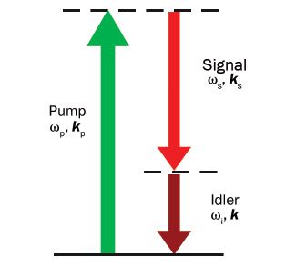

Figure 1. Schematic of the parametric process in OPOs. The process can be perceived as the splitting of an incoming pump photon of high energy into two photons of lower energy (typically denoted as signal and idler); it is subject to the conservation principles of photon energy (ωp = ωs + ωi) and photon momentum (kp = ks + ki + Δk). Courtesy of Hübner Photonics.

The basic scheme common to OPOs is illustrated in Figure 1. Simply speaking, the process can be perceived as splitting an incoming pump photon of high energy into two photons of lower energy, usually referred to as signal and idler photons, respectively. The overall process is subject to the conservation principles of photon energy and photon momentum (phase-matching condition), but it otherwise does not entail further fundamental restrictions, at least in theory. The huge potential of OPOs thus derives from their exceptional wavelength versatility, because they are, in principle, not limited by the wavelength coverage dictated by the energy levels and suitable transitions in a laser gain medium.
In practice, the OPO concept was experimentally demonstrated more than half a century ago², but the progress in development and commercialization of turnkey devices has been stalled substantially by several technical obstacles^{3.} These obstacles have been easier to overcome at the high peak powers of pulsed devices, and thus tunable OPOs operating in pulsed mode have become readily available from a variety of suppliers. Only recently have there been comparable advancements in CW OPO technology, which, in turn, have spurred the development of commercial systems 3.
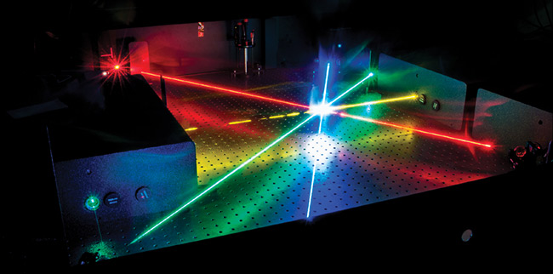

Optical parametric oscillator (OPO) technology provides laser light that is widely tunable across the visible spectrum. Courtesy of Holger Kock/Fraunhofer Institute for Physical Measurement Techniques IPM.

Progress has been mainly driven by the availability of cost-effective, high-performance CW pump lasers, along with the increasingly sophisticated design of new nonlinear crystals. As to pump lasers, the operation of CW OPOs puts stringent requirements on potential light sources in terms of preferential single-mode operation, noise characteristics, beam quality, and beam-pointing stability. Depending on power requirements, the end user can typically utilize either high-performance, diode-pumped solid-state (DPSS) lasers (for lower powers) or fiber-laser-based solutions (for higher powers). As to nonlinear materials and recent crystal design techniques, the emergence of quasi-phase-matched nonlinear materials, such as periodically poled lithium niobate (LiNbO₃), whose crystal structure alters with a certain periodicity, have been very useful for the design of practical optical parametric devices.
Practical design, performance
OPO technology is ideally suited for generating tunable CW laser light across arbitrary wavelength ranges, but its process always generates output at wavelengths longer than those used for pumping. Consequently, OPO devices operating across the visible spectrum require either UV pump sources or additional frequency-conversion stages. As of today, only the latter approach has proven to be technically practicable and operationally stable in commercial turnkey systems.
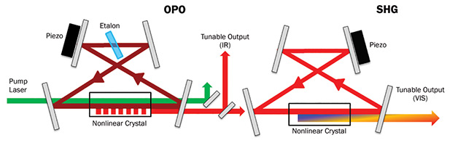

Figure 2. Schematic beam path inside a commercial CW OPO system (see reference 4). In a first step (OPO), a 532-nm laser pumps a nonlinear crystal to generate signal and idler photons (900 to 1300 nm). Wavelength selection and subsequent second-harmonic generation (SHG) converts either signal or idler photons into the visible range of the spectrum — 450 to 650 nm. Pump laser beam (green arrow); signal beam (dark red); idler beam (arbitrary assignment) (light red). Courtesy of Hübner Photonics.

The essential building blocks of a commercially available tunable CW OPO⁴, designed to cover the visible range, are shown in Figure 2. The operational principle relies on a cascaded sequence of nonlinear optical processes within two cavities, referred to as OPO and SHG (second-harmonic generation).
Pump laser photons are first split into pairs of photons of lower energy — signal and idler (Figure 1). The OPO scheme employed is commonly referred to as singly resonant OPO cavity design. For a particular operational wavelength of the entire system, the cavity is operated “on resonance” at either a particular signal wavelength or a particular idler wave- length. Thereby a precisely moveable stack of periodically poled nonlinear crystals allows broad wavelength coverage — for a particular wavelength selection, a crystal layer with a suitable poling is automatically selected, and its poling period further adjusted through a temperature-control loop. At the same time, the effective OPO cavity length is actively stabilized to a multiple integer of the selected operational wavelength.
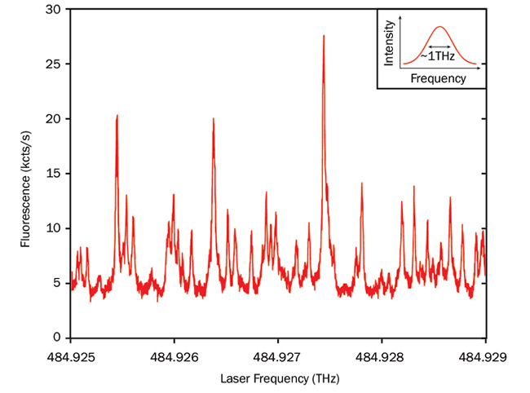

Figure 3. Excitation wavelength-dependent fluorescence intensity of dibenzanthanthrene (DBATT) molecules hosted in a naphtalene crystal at cryogenic temperature (see reference 6). The spectrum is recorded for a modehop-free scan over 4 GHz at a center wavelength of 618 nm. kcts/s: kilocounts per second. Courtesy of Tobias Utikal (Nano-Optics Group of the Max Planck Institute for the Science of Light).

While one of the generated (signal or idler) waves is circulating resonantly inside the OPO cavity, its counterpart can be extracted for wavelength conversion into the visible by another nonlinear process. As illustrated in Figure 2, this wavelength conversion takes place in a second, separate cavity by frequency doubling the primary OPO cavity output — the SHG process. Though this configuration is technically practicable and provides favorable operational stability, it should be noted that alternative designs, such as intracavity frequency doubling, have been successfully demonstrated in the lab^{1,3,5}.
In Figure 2, the typical CW OPO device encompasses continuous tunability across the range of 450 to 650 nm, delivery of high-quality laser light output with a typical linewidth of <500 kHz, and generation of output powers in the range of several hundreds of milliwatts. Notably, long-term frequency stabilities as good as ±1 MHz over 10 hours have been demonstrated when operating CW OPOs in closed-loop mode, in conjunction with external wavelength measurement devices⁴. Though the particular CW OPO design shown in Figure 2 has been optimized for pump laser wavelengths of 532 nm (in its commercialized version), the layout is generic enough to accept different pump wavelengths. These can be exploited to shift the overall wavelength coverage while keeping the same design principle.
Tunable OPOs at work
Not surprisingly, the sweet spots for implementing CW OPO technology are experimental settings that require narrow linewidths and significantly benefit from the accessibility of a wide tuning range, but are not too demanding in terms of output powers. Several examples are described below in an illustrative manner. Notably, the particular systems presented here are to be clearly distinguished in terms of the underlying physical phenomena that determine their spectroscopic signatures. However, in a broader perspective, all of the experiments are sensitive probes of nanoscale factors governing the light-matter interaction.
The fluorescence excitation spectra of single molecules can be demonstrated in a solid-state crystal at cryogenic temperatures⁶ (Figure 3). Under such conditions, individual molecules can be regarded as nearly ideal two-level systems with natural linewidths typically in the range of 10 to 50 MHz. Because of imperfections of the local surrounding crystal matrix, their transition energies are inhomogeneously distributed over a much wider spectral range. In the experimental data shown in Figure 3, the measurements unambiguously reveal several narrow spectral features within a scanning interval of 4 GHz, corresponding to individual molecules. It is further possible to lock the OPO wavelength in closed-loop mode to a selected single-molecule resonance for investigating its properties on an individual level.
There is a series of photoluminescence excitation spectra of so-called color centers in diamond that can be demonstrated at room temperature⁷ (Figure 4). Color centers are local defects (vacancies) in the diamond lattice related to impurities, and they have gained considerable attention over the last decade — not least as potential single-photon emitters, which are the heart of many promising quantum technologies such as quantum computing and quantum cryptography. Understanding the internal energy-level structure is of fundamental importance for future applications. CW OPO technology has enabled the spectroscopic characterization over a broad wave-length range (460 to 650 nm) at sufficiently high excitation intensities.
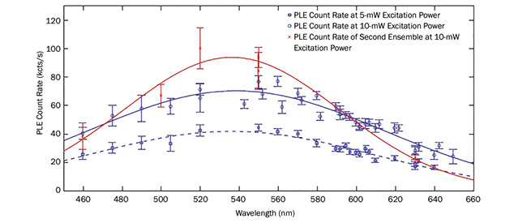

Figure 4. Photoluminescence excitation (PLE) spectra of a color center ensembles in diamond at room temperature (see reference 7). The data is recorded at different excitation powers across a series of excitation wavelengths between 460 and 650 nm. Blue squares and circles show measurements at 5 mW and 10 mW (respectively) of excitation power of one and the same ensemble. Red I-bars refer to measurements at 10-mW excitation power of a second ensemble. kc/s: kilocounts per second. Courtesy of Alexander Kubanek/Hybrid Quantum Systems Group at Ulm University.

A series of excitation energy-dependent Raman spectra of a mixture of single-wall carbon nanotubes (SWNTs) in ethanol solution can be seen in Figure 5. A carbon nanotube can be perceived as a strip of a graphene sheet rolled up into a cylinder along a chiral vector that is indexed by pairs of integers (n,m) and that determines its microscopic structure — tube diameter and the chiral angle along the tube axis. For characterizing the microscopic structure of SWNTs experimentally, Raman scattering is recognized as one of the main techniques⁸. Thereby, the most prominent signatures are radial breathing modes (RBMs), which correspond to collective movements of carbon atoms in the radial direction and are intimately linked to the SWNT diameter.
The usual Raman scattering signal is typically too weak to be of practical relevance. However, the Raman scattering efficiency is significantly enlarged if the laser energy matches the energy of optically allowed electronic transitions, an enhancement process referred to as resonance Raman scattering. For a particular laser excitation wavelength, the Raman signal from a mixture of SWNTs derives only from a particular subset that is in electronic resonance with the laser excitation. By systematically recording resonance Raman scattering spectra under continuous tuning of the excitation wave-length, in addition to subsequent comparison of the observed RBM frequencies with literature values, it is possible to assign the various (n,m) SWNT species present in a mixture. Figure 5 illustrates such an assignment of different tube species that are present in an ethanol solution.
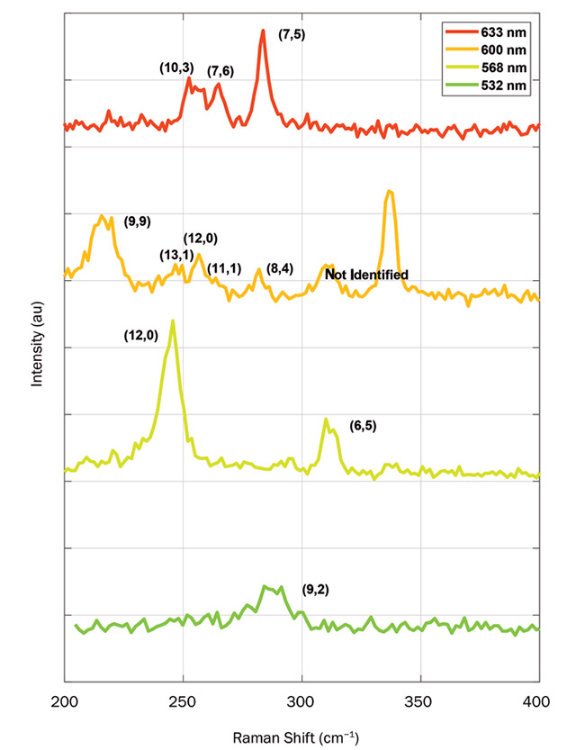

Figure 5. Resonance Raman scattering spectra of a mixture of single-wall carbon nanotubes (SWNTs) in ethanol solution (concentration of 1 g/l). The spectra are recorded for excitation wavelengths of 633, 600, 568, and 532 nm (top to bottom). The peak indices in parentheses (n,m) indicate the assignment of signals to SWNT of a particular chirality. Courtesy of Patryk Kusch/Stephanie Reich group. Free University Berlin.

Their performance characteristics make tunable CW OPOs competitive alternatives to conventional lasers and related technologies for the generation of widely tunable CW radiation in the visible spectral range. This particularly applies for a variety of experimental studies in molecular physics and quantum nano-photonics. We can predict further applications, whether in the form of refining and extending the experiments presented here to new samples, such as photoluminescence studies of novel types of single-photon emitters, or in the form of increasingly sophisticated experimental approaches such as state-of-the-art methodologies in Raman scattering of single molecules.

4) Invention of Optical “Tweezers” for Micro-robotical Surgery
https://www.elliotscientific.com/What-are-Optical-Tweezers

Optical Tweezers Overview - Elliot Scientific 2019
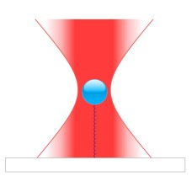

What are optical tweezers ..and how do they trap things using a laser?
Optical tweezers use a laser to trap microscopic dielectric objects, and a dielectric is defined as an electrical insulator that can be polarised (charged) by an application of an electric field.
In our scenario, a glass or polystyrene bead approximately 1 micron (µm) in diameter is a microscopic dielectric object.
Light can be described as an electromagnetic wave which, in classical physics, is a synchronised oscillation of an electric and magnetic field.
Modern physics describes light as having wave-particle duality in that it can behave both as wave or a particle, a photon... and photons can exert a physical pressure as they transfer the momentum of their movement to an object in front of them.
The greater the number of photons, the higher the force exerted. Yet even with the intense light from a near infra-red laser beam, the pressure on an object is still only a few trillionths of a newton - which is the international unit of force. However, this piconewton (pN) force is sufficient to hold and manipulate our microscopic bead.
The bead is attracted to the electric field, and the laser beam's focus or 'waist' is the area with the strongest pull. Once in the waist, it is trapped and can be moved around with ease.
This ability to move things on the sub-nanometre scale has enabled studies in the life sciences previously thought impossible. Research into the properties of DNA has advanced significantly due to the laser trapping ability of optical tweezers.
Scientists can sort or track viruses, living cells and bacteria with optical tweezers, even fold or unfold proteins by 'glueing' beads to these biological structures that can then be manipulated with the laser beam.
Measurements can be made as to how much force is required to do this, and these types of studies are typically used to determine the properties of molecular motors and DNA.
To avoid damage to the experiment, near infra-red laser beams operating with a wavelength of around 1 µm are often used. Biological samples, being mostly water, have a low absorption of this wavelength of invisible light, so tend not to quickly cook. Green lasers are also used in some cases.
Elliot Scientific can supply fully integrated optical tweezer systems comprising microscope, lasers, imaging system, optional force measurement, specialist software and the complex opto-mechanical design off the shelf, making it all work straight out of the box.
We can sometimes also add an optical tweezer capability to your existing microscope, so do contact us for more details about photonic force microscopes.
The first optical trapping systems were single beam open architecture lab experiments derived from the Ashkin paper published in 1986. Physics researchers then developed more complex double and multiple trap systems.
In 2003 Elliot Scientific and Professor Kishan Dholakia of St. Andrews University started a collaboration to develop an 'off the shelf' fully integrated optical trapping system. This meant that, for the first time, trapping experiments did not need a PhD researcher to build and operate optical tweezers... Elliot Scientific could deliver a unit that worked straight out of the box rather than taking six months to build and set up.
We started with single trap units, then dual beam traps, finally moving on to computer controlled multiple trap systems with force measurement and particle trapping included.
These integrated microscope systems comprise lasers, imaging system, optional force measurement, specialist software and superior opto-mechanical design. They are delivered to allow Bio/Microscopy researchers to start their relevant optical trapping experiments on day one. The technique becomes a useable tool and is no longer a research project.
Without the early work of Ashkin we would never have been able to develop the systems that we have today. - Mike Elliot
For more information please read: A Practical Guide to Optical Trapping

5) Whispering lasers into your ear via Ho:YAG Photoacoustic Shockwave Mechanism
https://www.extremetech.com/extreme/284743-mit-creates-lasers-that-whisper-in-your-ear

MIT Creates Lasers That Whisper in Your Ear

By Ryan Whitwam - ExtremeTech, Jan 2019
How do you whisper to someone across the room? With lasers, of course. MIT has developed a system using lasers to transmit audio signals directly to the ear, and no one else in the area can hear them. As a nice bonus, the laser won’t burn your skin or eyes should you turn your head at the wrong moment.
The laser system leverages what is known as the photoacoustic effect. That simply means that the absorption of light waves by a material produces sound waves. In this case, the light is absorbed by water molecules in the air, but the researchers learned to very carefully tune the laser to control where the sound appears. It’s essentially a narrow cone of sound.
Making sound with a laser is one thing, but creating specific tones or transmitting a message is much harder. The team evaluated two methods for doing this. First, there’s the laser sweeping technique, which involves altering the wavelength of light to create different sounds. The traditional photoacoustic method uses varying power to encode a message.
Both approaches have their strengths. The laser sweeping technique is the most impressive demonstration of the technology. It can transmit sound up to 2.5 meters away at 60 decibels. That’s equivalent to background noise in a busy restaurant. The photoacoustic approach isn’t as loud, so it won’t work as far away. However, it can produce sound with much higher fidelity.
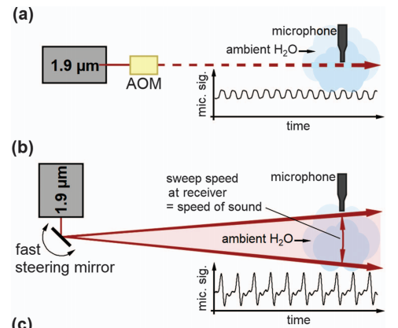
Currently, this is a fun tech demo. If you need to speak to someone far away, we have these devices called “phones” that make it very easy. However, there might be cases in which such technology is useful. Perhaps you don’t have someone’s phone number, but you want to relay some information quietly. They can’t reply, though. This is a one-way communication system — it’s unlikely the person you’re whispering to has their own talking laser. It’s also possible this technology could evolve into a warning system that alerts people to danger when they’re out of earshot. The latter application will require more work to extend the range and eliminate interference. The MIT researchers are planning to develop methods to extend the range of the lasers in outdoor settings to make that a reality. The team is shooting for 100 to 500 meters. Success could make this technology a viable commercial product.
6) A New Approach to Realization of the “Star Trek Cloaking Device”
https://www.livescience.com/60649-beam-of-invisibility-cloaks-objects-with-light.html

'Beam of Invisibility' Could Hide Objects Using Light
By Charles Q. Choi, Live Science Contributor - Live Science, Oct 2017

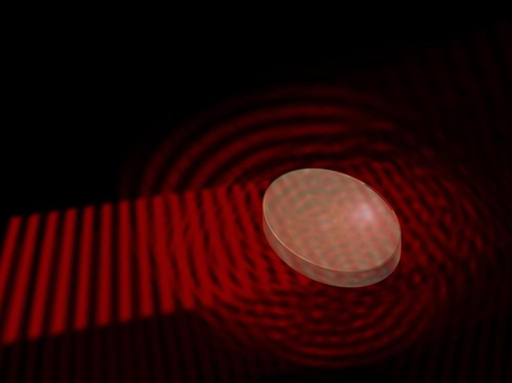
A material with random irregularities scatters an incident light wave into all directions.
Credit: TU Wien
Once thought of as the province of only "Star Trek" or "Harry Potter," cloaking technologies could become a reality with a specially designed material that can mask itself from other forms of light when it is hit with a "beam of invisibility," according to a new study.
Theoretically, most "invisibility cloaks" would work by smoothly guiding light waves around objects so the waves ripple along their original trajectories as if nothing were there to obstruct them. Previous work found that cloaking devices that redirect other kinds of waves, such as sound waves, are possible as well.
But the new study's researchers, from at the Technical University of Vienna, have developed a different strategy to render an object invisible — using a beam of invisibility. [Now You See It: 6 Tales of Invisibility in Pop Culture]
Complex materials such as sugar cubes are opaque because their disorderly structures scatter light around inside them multiple times, said study senior author Stefan Rotter, a theoretical physicist at the Technical University of Vienna.
"A light wave can enter and exit the object, but will never pass through the medium on a straight line," Rotter said in a statement. "Instead, it is scattered into all possible directions."
With their new technique, Rotter and his colleagues did not want to reroute the light waves.
"Our goal was to guide the original light wave through the object, as if the object was not there at all. This sounds strange, but with certain materials and using our special wave technology, it is indeed possible," study co-author Andre Brandstötter, a theoretical physicist at the Technical University of Vienna, said in the statement.
The concept involves shining a beam, such as a laser, onto a material from above to pump it full of energy. This can alter the material's properties, making it transparent to other wavelengths of light coming in from the side.
"To achieve this, a beam with exactly the right pattern has to be projected onto the material from above — like from a standard video projector, except with much higher resolution," study lead author Konstantinos Makris, now at the University of Crete in Greece, said in a statement.
The pattern that is projected onto an object to render it invisible must correspond perfectly to the inner irregularities of that item that usually scatters light, the researchers said.
"Every object we want to make transparent has to be irradiated with its own specific pattern, depending on the microscopic details of the scattering process inside," Rotter said in a statement. "The method we developed now allows us to calculate the right pattern for any arbitrary scattering medium."
Rotter and his colleagues are now carrying out experiments to see whether their idea will actually work. "We think that an experiment would be easiest to perform in acoustics," Rotter told Live Science. For instance, loudspeakers could generate sound waves to make a tube "transparent" to other forms of sound.
"For me, personally, the most surprising aspect is that this concept works at all," Rotter said. "There may be many more surprises when digging deeper along these lines."
Eventually, similar research could also experiment with light, he said. Such work could have applications in telecommunication networks, Rotter said. "It is clear, however, that considerable work is still required to get this from the stage of fundamental research to practical applications," Rotter said.

